Mauritania

## Respect for rule of law (ROL) data

The data set shows the data on the respect of the rule of law for the country.

## # A tibble: 19 x 5  
## country iso3c date ruleOfLaw ruleOfLawCategory4   
## <chr> <chr> <dbl> <dbl> <chr>   
## 1 Mauritania MRT 1996 -0.504 ROL moderately disrespected  
## 2 Mauritania MRT 1998 -0.482 ROL moderately disrespected  
## 3 Mauritania MRT 2000 -0.424 ROL moderately disrespected  
## 4 Mauritania MRT 2002 -0.523 ROL moderately disrespected  
## 5 Mauritania MRT 2003 -0.524 ROL moderately disrespected  
## 6 Mauritania MRT 2004 -0.729 ROL moderately disrespected  
## 7 Mauritania MRT 2005 -0.711 ROL moderately disrespected  
## 8 Mauritania MRT 2006 -0.785 ROL moderately disrespected  
## 9 Mauritania MRT 2007 -0.703 ROL moderately disrespected  
## 10 Mauritania MRT 2008 -1.14 ROL highly disrespected   
## 11 Mauritania MRT 2009 -0.805 ROL moderately disrespected  
## 12 Mauritania MRT 2010 -0.890 ROL moderately disrespected  
## 13 Mauritania MRT 2011 -0.915 ROL moderately disrespected  
## 14 Mauritania MRT 2012 -0.917 ROL moderately disrespected  
## 15 Mauritania MRT 2013 -0.998 ROL moderately disrespected  
## 16 Mauritania MRT 2014 -0.860 ROL moderately disrespected  
## 17 Mauritania MRT 2015 -0.866 ROL moderately disrespected  
## 18 Mauritania MRT 2016 -0.726 ROL moderately disrespected  
## 19 Mauritania MRT 2017 -0.599 ROL moderately disrespected

## Respect for rule of law (ROL) trend

The plot shows the trend of the respect for the rule of law for the country.

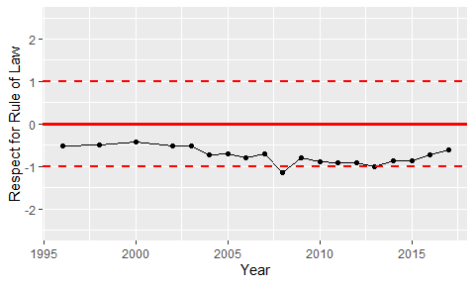

Trend of the Respect for the Rule of Law